Algorithm

So the basic idea for algo is - “Clustering of like minded people, with an assumption that ppl with similar taste, eating habits, spending power etc will like similar places”.

Input from the user and how to obtain:
Assumptions:
- Let’s call our app - “REC”
- User’s mobile phone can provide GPS location
  - Alternate to GPS = network cell id
- http://developer.android.com/guide/topics/location/obtaining-user-location.html
- http://stackoverflow.com/questions/6694391/android-get-current-location-of-user-without-using-gps-or-internet

Recommendation

Inputs - List of all inputs for algorithm:
- Facebook Profile
- Location
- Time – opening hours for restaurant
- Cost
  - Zomato API provides this value (approx. cost for 2).
- Age – FB connect
- Sex – FB connect
- Ethnicity - TBD
- Native Place -TBD - eg: people form Delhi are more likely to like paneer tikka then dosa or vada, both being starters.
- Willingness to travel – for later release - distance he would prefer to travel from his current location
  - Identify usage pattern for the user based on his location
  - Ideally, there would be two locations from which the user would access REC most and based on time of day and day of week it is accessed, it can be determined which one is home and work place with reference to the user
  - Now, take the checkins from social media, specifically for places identified as “hangout” places. Or the places he has marked as visited.
  - Based on all this, it can be estimated, how much distance, this user is willing to travel to reach a recommended restaurant based on proximity to his home/office, time of day and day of week.
- Rate the any 5 restaurants (from a list) - one time, during setting up of profile
- List to be created based on user location - some restaurant for which we already have some user’s rating/reviews etc
  - Bad
  - Average
  - Like it
  - Love it
  - Any Recommended Dish (optional)

- Intuitive questions, TBD
  - What kinda drink you like
    - Beer
    - Spirits
    - Juices

  - Provide predefined reviews to choose from, eg :
    - Like the ambiance but was a but food wasn't good
    - Less options
    - It was awesome
    - It was good but too costly
    - Stupid dumb fuck!
c. Any super awesome dish?
- Restaurants Attributes:
  - Location
  - Contact
  - city
  - cuisines
  - timings
  - Avg Cost For Two
  - Is Pure Veg
  - Bar
  - DineIn
  - Delivery
  - Rating
    - food
    - service
    - ambience
    - overall
  - Discounts
  - Buffet
  - Live Music
  - happy hour details
  - Photos
  - URL

- User views the recommendation but does not provide any action in the app. He might still consider that recommendation, without taking or providing any further info to the user. Hence user browsing is also taken into account as an input to the algorithm.
TBD : More research on user behavior for such scenario.

Specific Filters to be applied on the result generated from Algo

- Apply a filter on results generated for a user => remove items which user has already visited. This is a very good point. But we for sure cannot remove it from the list of recommended restaurants. I think instead it should be like, if a user gave very bad rating to some restaurant, then we never suggest that even if our recommender might give that as a recommendation. If I like some restaurant I would like to go to that restaurant again but not in near future. so Maybe not suggest that restaurant for certain time after user has visted that restaurant.
- Specific Filters which can be applied by user:
  - Budget
  - Today I want hang out with my friends - so if the user likes alcohol - then only suggest the places which servers alcohol
  - Today I want to go out with my family - some nice family eating place, which may not necessary serve alcohol
  - I feel like eating specific cuisine today.
  - We can also add a feature like a user want to go out with a big group of people (like team outings in company) and they have a fixed budget....so we can suggest places that fits the user budget along with the other inputs from user (like cuisine and location) –
[kumar] This requires number of inputs from user and additional calculation on our part. Also, this is entirely different from core algorithm. Its is a specific search based on inputs from user. Hence, I think this should not be a part of our app, at least first version.

Inputs - for first version:

- FB account - age, sex, hometown, current city
- Location - phone=GPS/network cell, website=user input/ip filtering
- Restaurant Attributes
- Rate five restaurants: will give a basic profile for user likes/dislikes - one time for profile builder
- Explicit filters – overrides on result generated
- Reviews/Rating based on user’s sharing data
- Additional feature for user to build his profile - would be completely optional for user
  - Question to be asked – Try to come up with questions, for which the answer is YES or NO, instead on user requiring to type anything.
    - What kinda of cuisines u like ? - multiple inputs
    - Kinda place u prefer - lounge, bar, bristo, cafe, dhaba, street food - multiple inputs.
    - Price range – slider input
    - Veg or Non-Veg
    - What kinda drink u like?

User Login:
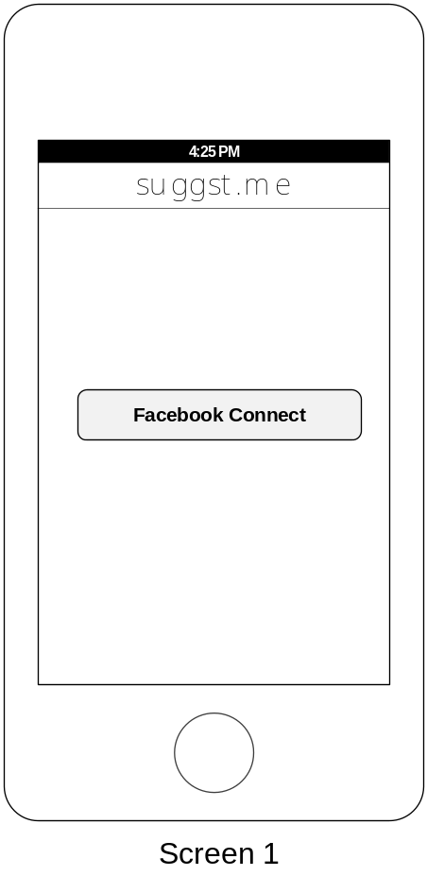

Profile Builder

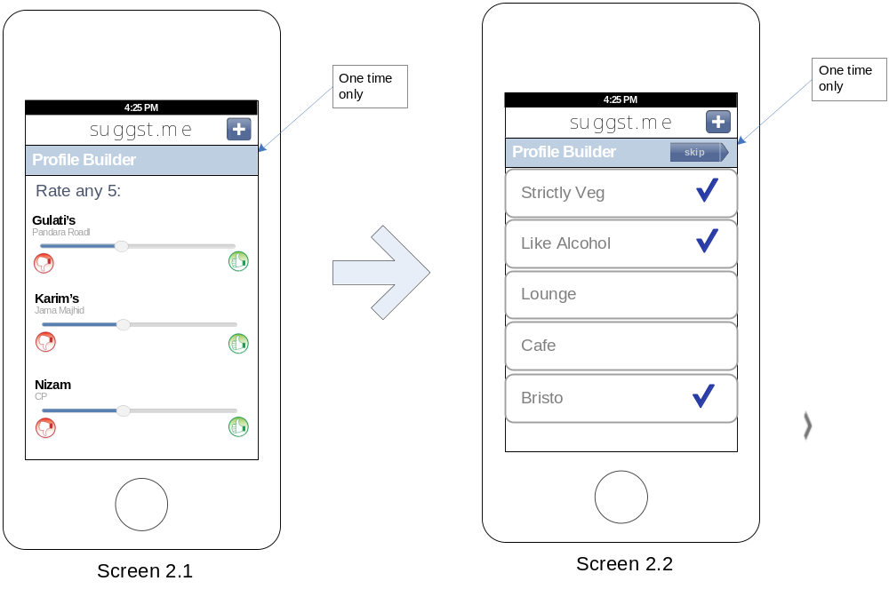

First Screen After Login:

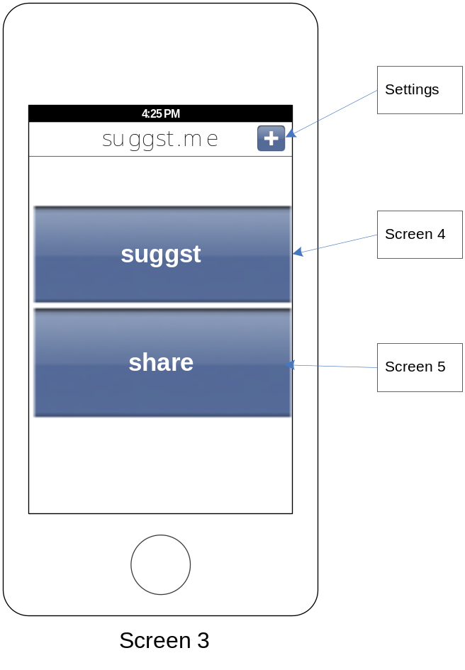

Suggestion - Output:
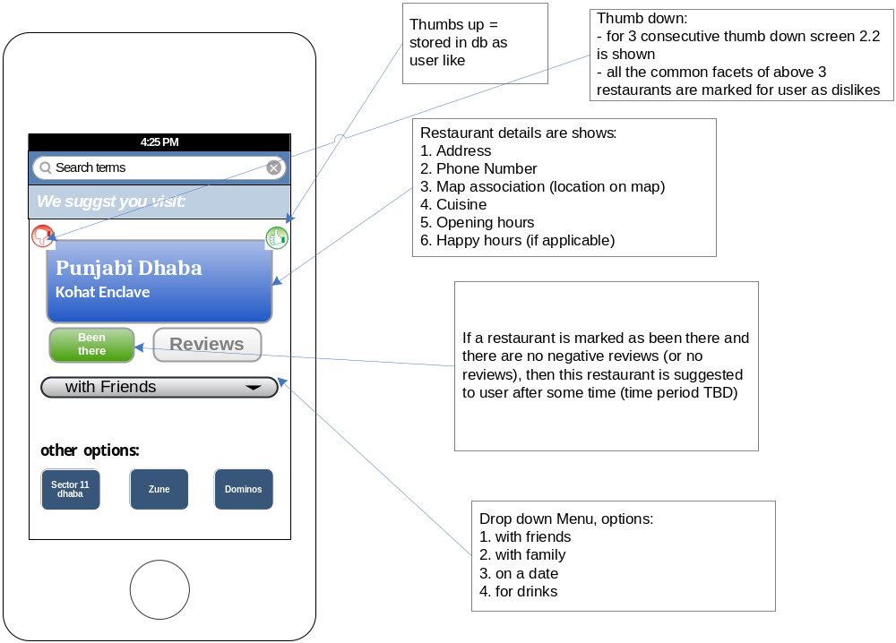

Share – Output:
Need a profanity filter here
Actually anywhere with user input that goes public. Don't know what we can do regarding pics other than having a "report abuse" button.
we can use this for start : http://dansguardian.org/
for pics, i guess we will have to do it manually, atleast until we have a large number of pics... on second thoughts if we reach that stage we can hire somebody to do it ;)

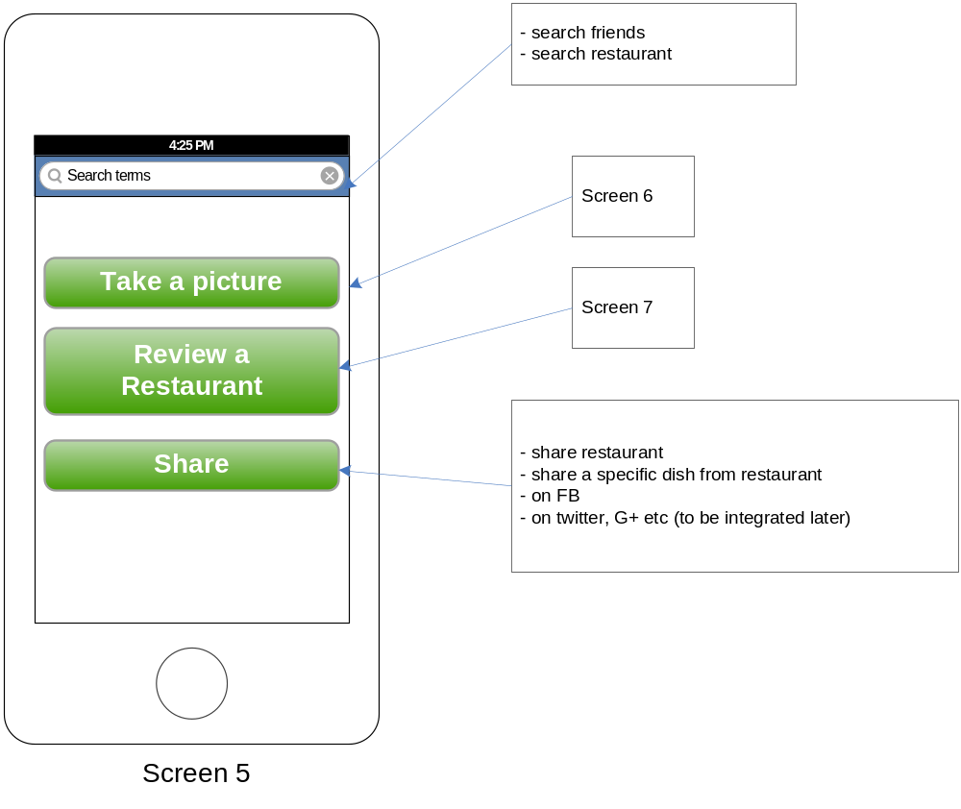

Review Restaurant

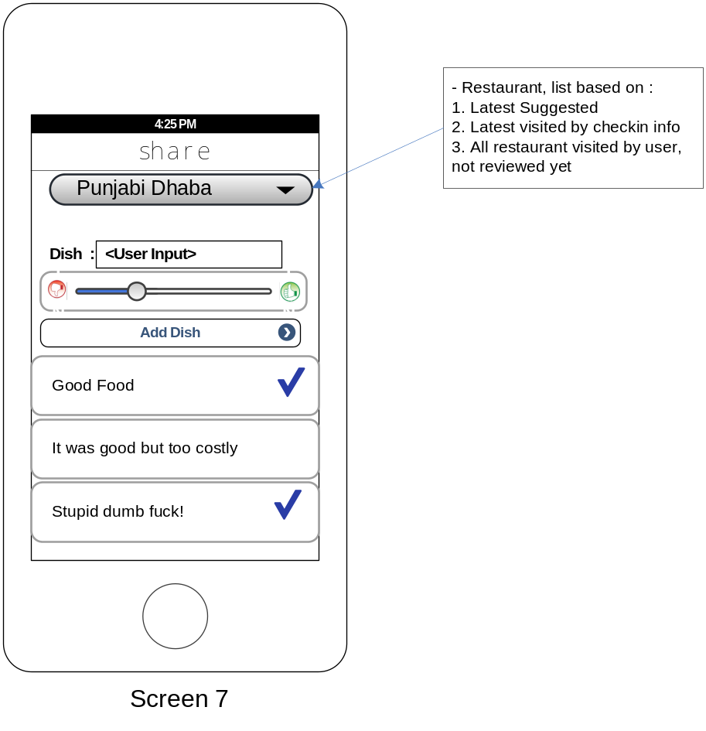

Other questions which can be asked:
- Food - Slider
- Service - Slider
- Ambiance - Slider
- Variety - Slider
- Do you want to come back to this place? – YES/NO

Take a Picture:

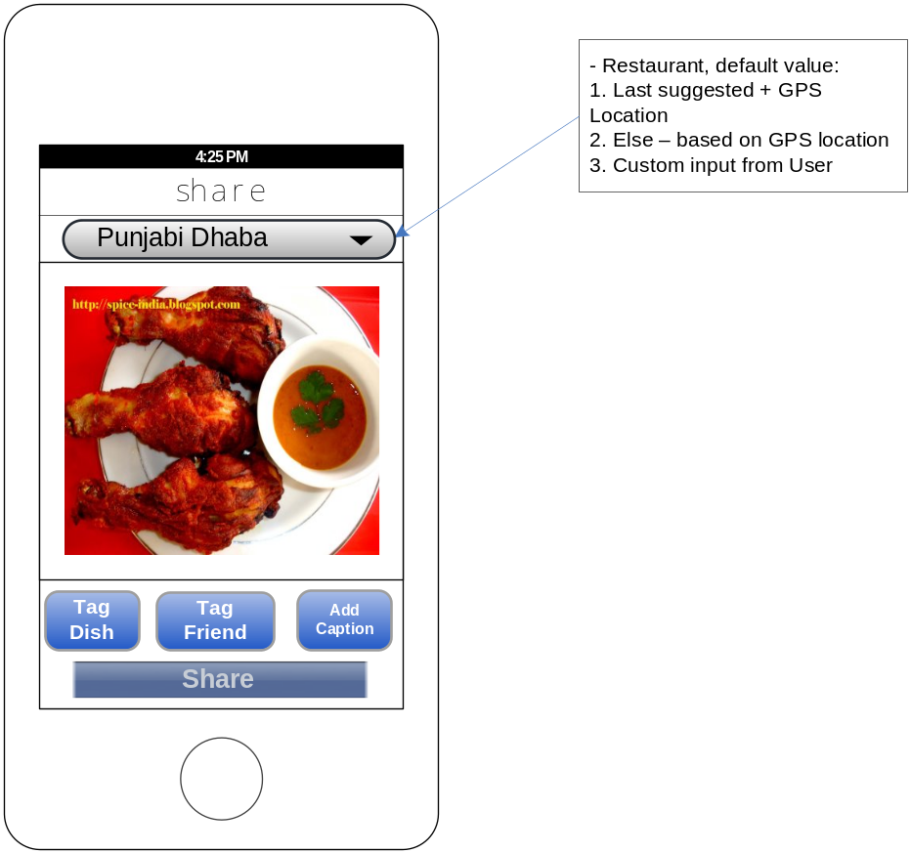

User Engagement:
How to drive user engagement, encourage user to provide reviews/ratings and other feedback.
As DG suggested, we can use game mechanics to solve this problem.

Taking the example from Yelp.

Yelp!
The Problem: Getting consumers to provide in-depth, interesting reviews on local businesses.
The Solution: Creating a status symbol to encourage participation and brand evangelism.
Each member has a profile, which includes the number of reviews posted, how many "friends" you have, how many times you’ve been the first to review a business and whether your reviews are funny, useful or cool, among other things.
Every activity is tracked with the intention of creating a more integrated and personal community.
The essence of Yelp! is in its community and in providing easy ways to engage with others on the site is what keeps people engaged and active.
Without some kind of interaction, most reviewers would lose interest.

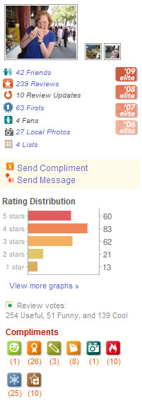

Example of a user profile on Yelp!.
To take it a step further, Yelp! capitalized on its most dedicated users by allowing them to apply for the Yelp! Elite Squad. This is not much more than an extra profile icon, but it creates a passionate group of brand evangelists who not only provide excellent reviews (for free!), but tell others about your service and how great it is.
Yelp! has successfully been able to leverage status to act as an engine for generating more content and encouraging word of mouth.

